1. Write a program that prints the output as shown in output section using input shown in input section

**Input:**

[

{text: 'ES6 is awesome', type: 'p’},

{text: 'ES6 is significant update in JS history', type: 'li’},

{text: 'const creates immutable variables', type: 'li’},

{text: 'Block scoping via let and const', type: 'li’},

{text: 'ES6 was released in 2015', type: 'h3’}

];

**Output:**

Element type is li with text ES6 is significant update in JS history

Element type is li with text const creates immutable variables

Element type is li with text Block scoping via let and const

**Concepts to use:**

* Block scoping
* Arrow functions
* Template literals
* Destructuring
* For-of loop

1. Implement function called **calculatePrice** that simulates named parameters concept. **calculatePrice** takes 3 params named price, tax and discount, out of which discount is default with 10.

**Logic to use:**

taxablePrice = price - (price * (discount / 100))

priceWithTax = taxablePrice + (taxablePrice * (tax / 100));

**Concepts to use:**

* Block scoping
* Arrow functions
* Destructuring

1. Create a class called TableGenerator, which contains data and title properties. Develop render method which generates html markup as table for given input data.

Input**:**

let data = [

{title: 'apple', price: 2, qty: 30},

{title: 'banana', price: 1, qty: 30},

{title: 'chikoo', price: 1, qty: 30}

];

title = “fruits”

Output:

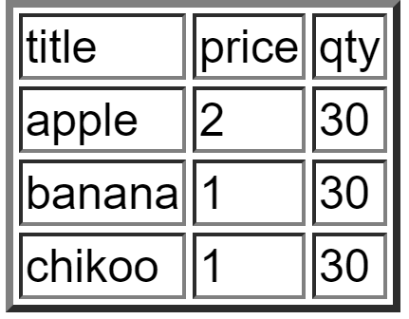

1. Create a promise based code that echoes input 5 times after a give delay
2. Create a generator function that returns 10 random numbers between 10 and 50
3. Create a generator function that calculates foreign exchange price between given currencies

Use: <https://api.fixer.io/latest?base=USD>

exhcangeRate(from,to,amount)

exhcangeRate(USD,INR,100)

1. Code a function that uses iterable / iterator protocol to fetch keys of object and their values

Input: { name: ‘zeo’, age:20, grade:’A’}

Output: name -> zeo

age -> 20

grade -> A